PANDEMIC PREVENTION SYSTEM BASED ON MQ3 SENSOR INTERFACED WITH RFID AND SERVO MOTOR

M.Sridhar

Department of Electronics and Communication Engineering

Student (ECE) at - Sri Balaji chockalingam engineering college, Thiruvannamalai, India

A.Kirubhanithi, DECE

Department of Electronics and Communication Engineering

Student (ECE) at - Sri Balaji chockalingam engineering college, Thiruvannamalai, India

M.Vijay, DECE

Department of Electronics and Communication Engineering

Student (ECE) at - Sri Balaji chockalingam engineering college, Thiruvannamalai, India

P.Hariharan

Department of Electronics and

Communication Engineering

Student (ECE) at - Sri Balaji

chockalingam engineering

college, Thiruvannamalai, India

**Abstract** – During viral pandemic situations, the virus can spread in a large number of areas in a very short time. To reduce the spreading of the virus, we will introduce this project - a pandemic prevention system based on an MQ3 sensor with RFID and a servo motor.

**I. INTRODUCTION**

In this project, we can introduce two concepts based on sanitizer detection using an MQ3 sensor with RFID and a Servo motor. The first concept is RFID Based attendance-making system interfaced with MQ3 sensors for companies and colleges. The second concept is an automatic door-opening system using a Servo motor interfaced with an MQ3 sensor.

**II. WORLD HEALTH ORGANIZATION (WHO) ABOUT PANDEMIC PREVENTION METHODS**

Protect yourself and those around you by Getting vaccinated as soon as it’s your turn and following local guidance on vaccination. Keep a physical distance of at least 1 meter from others, even if they don’t appear to be sick. Avoid crowds and close contact. Wear a properly fitted mask when physical distancing is not possible and in poorly ventilated settings. Clean your hands frequently with alcohol-based hand rub or soap and water. Cover your mouth and nose with a bent elbow or tissue when you cough or sneeze. Dispose of used tissues immediately and clean hands regularly. If you develop symptoms or test positive for COVID-19, self-isolate until you recover.

**Importance of hand sanitizer:** Wearing glows risks the transmission of germs from one surface to another and contaminates your hands when removing them. Wearing glows does not replace cleaning hands. The virus is still alive around 7 hours in a glows. But the hand sanitizer destabilizes the virus in our hands within 15 seconds.

**III. DEVELOPMENT BOARD**

**ARDUINO UNO:** In this project, we can use Arduino uno as a development board to make an automatic door-opening system using a servo motor interfaced with the MQ3 sensor. The price of this board is the lowest compared to other Arduino products. Arduino UNO is a microcontroller board based on the  **ATmega328P**. It has 14 digital input/output pins (of which 6 can be used as PWM outputs), 6 analog inputs, a 16 MHz ceramic resonator, a USB connection, a power jack, an ICSP header, and a reset button. We can dump any programs in Arduino uno with the help of Arduino IDE (open source) software. The Arduino supports the embedded C-like program.

**NODE MCU (ESP 8266):** In this project, we can use NODE MCU as a development board to make IOT based attendance marking system with the help of an RFID reader and MQ3 sensor.The NodeMCU (Node MicroController Unit) is an open-source software and hardware development environment built around an inexpensive System-on-a-Chip (SoC) called the ESP8266. The ESP8266, designed and manufactured by Espressif Systems, contains the crucial elements of a computer: CPU, RAM, networking (WiFi), and even a modern operating system and SDK. That makes it an excellent choice for Internet of Things (IoT) projects of all kinds.

There are four power pins. **VIN** pin and three  **3.3V**  pins. **VIN**  can be used to directly supply the NodeMCU/ESP8266 and its peripherals. Power delivered on **VIN** is regulated through the onboard regulator on the NodeMCU module – you can also supply 5V regulated to the **VIN** pin, **3.3V** pins are the output of the onboard voltage regulator and can be used to supply power to external components.

NodeMCU/ESP8266 has 17 GPIO pins which can be assigned to functions such as I2C, I2S, UART, PWM, IR Remote Control, LED Light, and Button programmatically. Each digitally enabled GPIO can be configured to internal pull-up or pull-down, or set to high impedance. When configured as an input, it can also be set to edge-trigger or level-trigger to generate CPU interrupts.

**IV. MQ3 SENSOR**

It is a low-cost semiconductor sensor that can detect the presence of alcohol gases at concentrations from 0.05 mg/L to 10 mg/L. The sensitive material used for this sensor is SnO2, whose conductivity is lower in clean air. Its conductivity increases as the concentration of alcohol gases increases. The MQ3 sensor is capable to detect ethanol that in gas form. MQ3 alcohol sensor module can be easily interfaced with Microcontrollers, Arduino Boards, Raspberry Pi, etc. This module provides both digital and analog outputs. The MQ3 alcohol sensor operates on 5V DC and consumes approximately 800mW. It can detect alcohol concentrations ranging from 25 to 500 ppm.

When a SnO2 semiconductor layer is heated to a high temperature, oxygen is adsorbed on the surface. When the air is clean, electrons from the conduction band of tin dioxide are attracted to oxygen molecules. This creates an electron depletion layer just beneath the surface of the SnO2 particles, forming a potential barrier. As a result, the SnO2 film becomes highly resistive and prevents electric current flow. In the presence of alcohol, however, the surface density of adsorbed oxygen decreases as it reacts with the alcohol, lowering the potential barrier. As a result, electrons are released into the tin dioxide, allowing current to freely flow through the sensor.

**V. BASIC CONCEPT**

The MQ3 sensor is capable to detect ethanol that in gas form. Hand sanitizers contain 60% to 80% of ethanol in it. By detecting hand sanitizer, we can build lots of protection methods by using electronics. This module provides both digital and analog outputs. The analog output is used to provide the ethanol percentage in gas vaporized during hand sanitization. By this, we can find the effectiveness of hand sanitation. In this project we can build a sanitizer-based attendance-making system by using an RFID reader interfaced with the MQ3 sensor also we can make an automatic door-opening system using a servo motor and interface with the MQ3 sensor.

The MQ3 sensor is used to sense the ethanol content in hand sanitizer. The MQ3 provides a both digital and analog output. The digital output is used to indicate whether the hands are sanitized or not through the LED used. The analog output is used to indicate whether the right amount of sanitizer is used or not. If the percentage is above 65% it is an acceptable minimum amount of sanitizer is used for hand sanitization. The green and red LEDs are used to indicate whether the hands are sanitized are not. The 16x2 LCD is used to display the MQ3 sensor’s analog output.

**VI. RFID-BASED ATTENDANCE-MAKING SYSTEM INTERFACED WITH MQ3 SENSOR**

**FIRST CONCEPT:** In the above, we discussed the NODE MCU (ESP 8266) used for this attendance-making system. Because we want to save the attendance online, for this the NODE MCU is used. We can connect the NODE MCU to the internet with the help of hotspot technology.

In the below block diagram, the NODE MCU is interfaced with the MQ3 sensor and RFID reader. The 5v DC power supply is provided to the NODE MCU and the 3.3v DC supply is provided to the RFID reader. According to the MQ3 sensor data, the output is interrupted based on conditions written in NODE MCU.

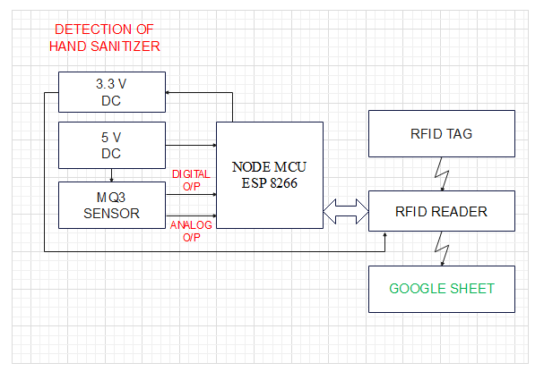

Figure 1.1 - Block diagram of RFID attendance-making system interfaced with the MQ3 sensor

If the digital output of the MQ3 sensor is HIGH then the system can allow you to register your attendance. If the digital output of the MQ3 sensor is LOW then the system can’t allow you to register your attendance. After reading of RFID card by the RFID reader, then the NODE MCU makes attendance according to the UID of the card. The generated attendance is updated in the Google sheet. By using this method hand sanitation is mandatory. So, the spreading of the virus through hands is reduced.

**VII. AUTOMATIC DOOR OPENING SYSTEM BY USING SERVO MOTOR INTERFACED WITH MQ3 SENSOR**

**SECOND CONCEPT:** In the above, we discussed the automatic door opening system is done by using a servo motor interfaced with the MQ3 sensor. Here we use the Arduino uno. We want more number I/O pins because we use LCD, MQ3 sensor, and LED. So, we want more number I/O pins, for this, we mostly prefer an Arduino uno development board.

In the below block diagram, the 12v Dc supply is provided to the Arduino development board, 5v DC supply is provided to the MQ3 sensor, LCD, servo motor, and LED indicators. The door is opened and closed based on the analog output voltage. If the analog out is reach the threshold level then the door is opened. The door closed after a few seconds that time can be controlled by using the right amount of resistor at the output of the MQ3 sensor. The inverter circuit is used to control the direction of the servo motor.

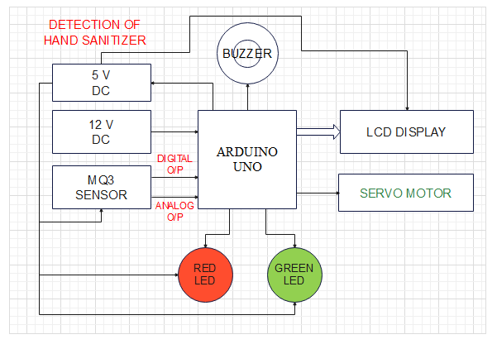

Figure 1.2 - Block diagram of Automatic door opening system using servo motor interfaced with the MQ3 sensor

The digital output of the MQ3 sensor is used to control the LED indicators. If the MQ3 sensor output is LOW then the RED LED is in ON condition and GREEN LED is in OFF condition to indicate there are no hands sanitized. If the MQ3 sensor output is HIGH then the RED LED is in OFF condition and GREEN LED is in ON condition to indicate the hands are cleanly sanitized. By using this method hand sanitation is mandatory. So, the spreading of the virus through hands is reduced.

**VIII. CONCLUSION**

We Conclude by Using these two devices can reduce the transmission of viruses through hands. When a product can reach all category of people then the product is known as a successful product in the market and make a profit. The MQ3 sensor, NODE MCU and Arduino uno are very low-cost devices, So small shops also can easily afford these products. Definitely, this product can contribute to reducing the transmission of viruses in pandemic situations and also make a profit to the manufacturer, and very helpful to people to avoid virus transmission.

**IX. REFERENCE**

[1]. De Sousa A. Disulfiram ethanol reaction in a patient abstinent from alcohol caused by hand sanitizing. *Alcohol Alcohol.*2020;55:349. [[PubMed](https://pubmed.ncbi.nlm.nih.gov/32400875)] [[Google Scholar](https://scholar.google.com/scholar_lookup?journal=Alcohol+Alcohol&title=Disulfiram+ethanol+reaction+in+a+patient+abstinent+from+alcohol+caused+by+hand+sanitizing&author=A+De+Sousa&volume=55&publication_year=2020&pages=349&pmid=32400875&)]

[2]. V. Verhoeven, G. Tsakitzidis, H. Philips and P. Van Royen, "Impact of the COVID-19 pandemic on the core functions of primary care: Will the cure be worse than the disease? A qualitative interview study in Flemish GPs", BMJ Open, vol. 10, no. 6, Jun. 2020.

[3]. T. P. B. Thu, P. N. H. Ngoc, N. M. Hai and L. A. Tuan, "Effect of the social distancing measures on the spread of COVID-19 in 10 highly infected countries", Sci. Total Environ., vol. 742, Nov. 2020.

[4]. J.-P. Bonardi, Q. Gallea, D. Kalanoski and R. Lalive, "Fast and local: How did lockdown policies affect the spread and severity of the COVID-19", Covid Econ., vol. 23, pp. 325-351, Jun. 2020.

[5]. N. Askitas, K. Tatsiramos and B. Verheyden, "Lockdown strategies mobility patterns and COVID-19", arXiv:2006.00531, 2020.

[6]. Brewer C, Streel E. Is alcohol in hand sanitizers absorbed through the skin or lungs? Implications for disulfiram treatment. *Alcohol Alcohol.*2020;55:354–356. [[PMC free article](https://www.ncbi.nlm.nih.gov/pmc/articles/PMC7454269/)] [[PubMed](https://pubmed.ncbi.nlm.nih.gov/32400852)] [[Google Scholar](https://scholar.google.com/scholar_lookup?journal=Alcohol+Alcohol&title=Is+alcohol+in+hand+sanitizers+absorbed+through+the+skin+or+lungs?+Implications+for+disulfiram+treatment&author=C+Brewer&author=E+Streel&volume=55&publication_year=2020&pages=354-356&pmid=32400852&)]

[7]. R. A. Fahey and A. Hino, "COVID-19 digital privacy and the social limits on data-focused public health responses", *Int. J. Inf. Manage.*, vol. 55, Dec. 2020.